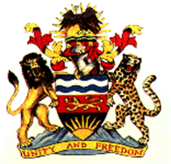 |  | 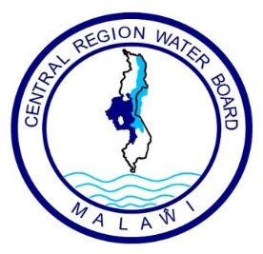
Ministry of Water and Sanitation |  | Central Region Water Board

Request for Bids – Works

Employer: Central Region Water Board
Project: Ntchisi Town Water Supply and Sanitation Project
Contract Title: Rehabilitation, Upgrading and Expansion of Ntchisi Water Supply Scheme and Construction of Sanitation Facilities
Country: Malawi
Procurement Reference No.: CRWB/GoM/W/NS/2024/01
Procurement Method: International Competitive Bidding (ICB)
Issued on: 10th July 2024
- Central Region water board through the Government of Malawi has received funding under the Public Sector Investment Program (PSIP) toward the cost of the Ntchisi Town Water Supply and Sanitation Project, and intends to apply part of the proceeds toward payments under the contract for Rehabilitation, Upgrading and Expansion of Ntchisi Water Supply Scheme and Construction of Sanitation Facilities.
- The Central Region Water Board now invites sealed Bids from eligible Bidders for the following Works:
- Raw water intake works
- Gravity raw water mains
- Water Treatment works
- Pump station
- Pumping mains
- Water storage reservoirs
- Distribution mains
- Construction of Scheme Office and Dwelling Houses
- Ablution blocks for Ntchisi Secondary School
- Construction of Solar PV System.
The Works shall be completed within 18 months.
- Bidding will be conducted through international competitive procurement using Request for Bids (RFB) as specified in the Malawi Public Procurement and Disposal of Assets act 2017 guidelines, and is open to all eligible Bidders as defined in the Procurement Regulations.
- A pre-bid meeting shall take place on 30th July 2024 at Central Region Water Board Offices from 08:30 Hours. Site visit will also be on the same day.
- Interested eligible Bidders may obtain further information from the Central Region Water Board and inspect the Bidding document during office hours 07:30 to 16:30 hours (local time) at the address given below.
- The Bidding document in English may be purchased by interested eligible Bidders upon the submission of a written application to the address below and upon payment of a nonrefundable fee of MWK 50,000. The method of payment will be cash at Central Region Water Board Head Office Cashier’s Pay Point.
- Bids must be delivered to the address below on or before 23 August 2024, 14:00 local time. Electronic bidding will not be permitted. Late Bids will be rejected. Bids will be publicly opened in the presence of the Bidders’ designated representatives and anyone who chooses to attend at the address below on 23 August 2024, 14:00 local time.
- All Bids must be accompanied by a Bid Security which is 2 percent of the total bid price in Malawi kwacha.
- The contact and address referred to above is:
Chief Executive Officer
Attn: Chairperson – Internal Procurement and Disposal Committee
Central Region Water Board
Murry Road, Off Paul Kagame Highway
P. Bag 59
Lilongwe
MALAWI
Tel: +265 (0) 310002128
E-Mail: crwb@crwb.org.mw

USE TENDER BOX FOR SUBMISSION

